**Practice 2.2**

**Introduction to business management**

Laura Baena Márquez

David Ramírez Machado

Santiago Rafael López Sindony

Alejandro Enrique González Núñez

**Computer Science, group 88**

***Steam***

Steam is a multi-platform based video game distributor developed on 2003. It is a free software that allows users to purchase video games for Windows, Mac and Linux.

When Steam was created the PC video game industry was suffering from a crisis (the vast majority of new games were mostly for video consoles). This was caused by piracy and the enormous time it took to download game updates (which had to be done manually).

At the beginning, Steam was a software which served as an automatic update downloader (it helped to prevent cheating). It was soon included in all new games, which required an Steam account. Some time later, it began to become the platform it is now, including a chat for users and after that it included its best known function: the purchase of video games.

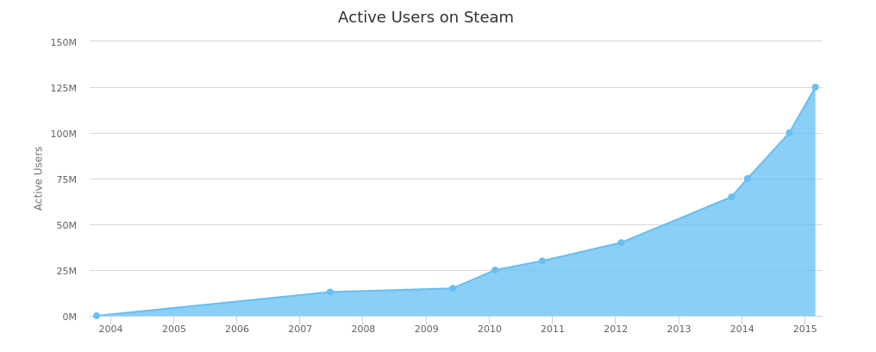

Its main features nowadays are: massive video game libraries, intuitive user interface, automatic game update, social network service, in-game voice call and chat functionality and cloud saving for progress and user profile.

Users’ feedback is important in order to improve the platform, used to analyze factors as: monthly active users, daily logins, customers ratings, most selling games, top grossing, trendings, top rated games, and many more.

The main advantage for customers (and the most important reason why they buy games through Steam) is that all purchased games can be kept in a single place. However, the other features that Steam offers are attractive too.

On the other hand, the main advantage for producers is that Steam supports all sorts of companies, you can find from unknown indie games to AAA games productions. The company offers a service called Steamworks which is a set of tools and services that help game developers and publishers build their games and afterwards distribute them on Steam.

Publishers are attracted to Steam for the anti-piracy measures that they offer, like the assignment and distribution of product keys, and support for digital rights management software tools. This allows game developers to have more confidence that their product won’t be hacked or stolen.

Steam’s strategy to stay ahead is constantly include large amounts of new games in its library and earning a percentage of each sale. Moreover, it takes advantage of the lowered cost of transportation and marketing by the digital games distributors, so, the platform can offer cheaper prices than buying a physical copy of the game. This allows Steam to constantly throw big sales.

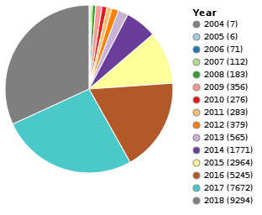

(Number of games distributed by Steam through the years)

The fact that they came up with the idea first is also part of this company’s success. So, it is natural that other services have been trying to emulate it. The most notable competitors are Electronic Arts' (EA) Origin service and Epic Games.

As a conclusion, Steam offered a service to solve an industry problem (they took advantage of an already existing market [video games]) and afterwards they started to include features to stay connected to the users (created an ecosystem). Those functionalities made it popular today. The main strategy they follow to encourage purchases is lowering the prices through big sales and offering a convenient way of game storage. To motivate producers, they distribute their creations so they can avoid extra expenses in manufacture and distribution. And, they also help developers by offering security and promotion.